Analysis Professional Capital

We have analysed the factor structure of the PC index data on teachers. The material is based on 712 respondents. We have used Principal Component Analysis (PCA) with Varimax Rotation. We have managed to reduce the PCA down to three factors. As you can see below, we are left with 5 problematic items (marked with xxx):

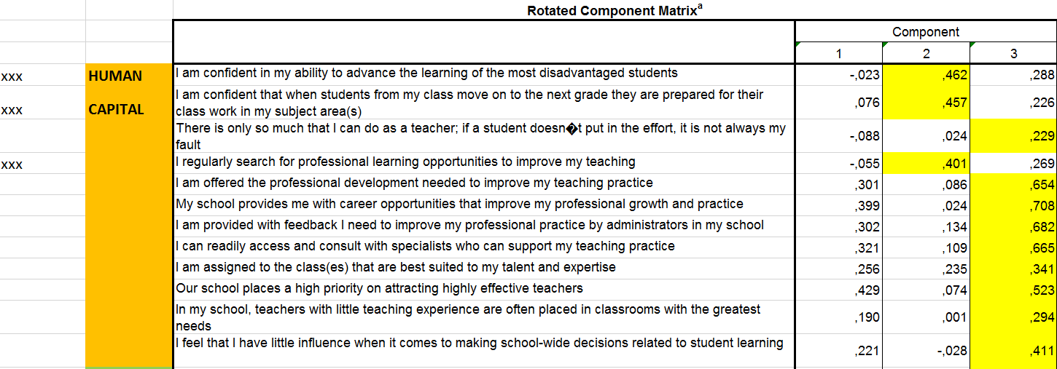
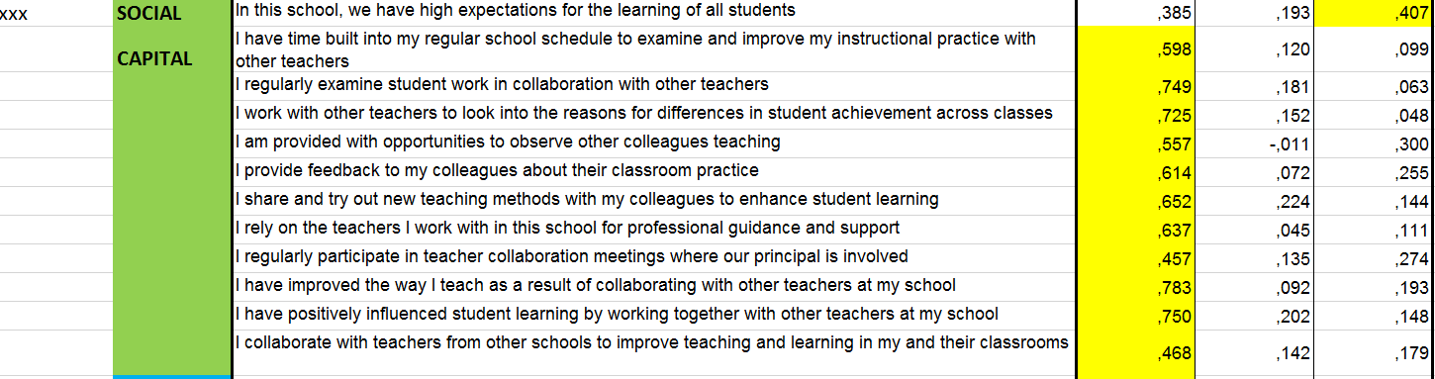
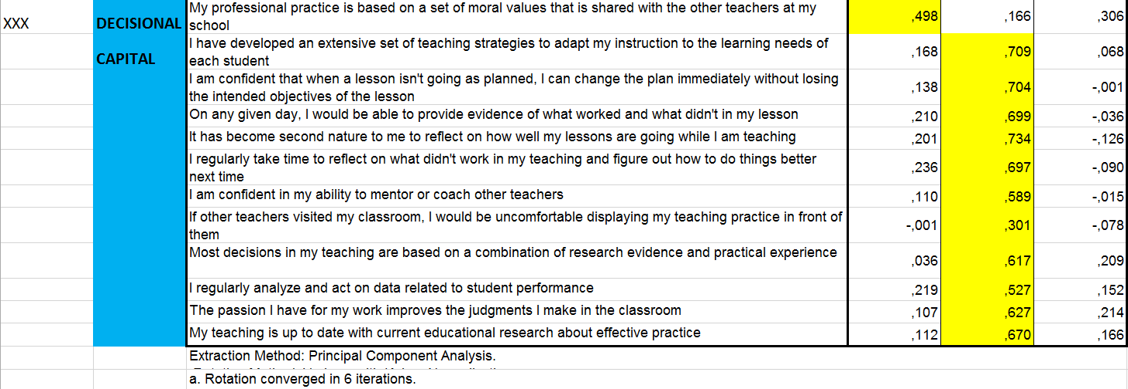

It seems that the two first items on HC load with DC due to the formulation “I am confident…”
It seems that the third item on HC load on DC due to the formulation “I regurlary search…”
The fourth item loads well on SC, but even more on HC, probably due to too little emphasis on “colleagues” and “collaboration”, and too much emphasis on “high expecations” and “this school”
The fifth item loads on both SC and HC, but not on DC, as it should. It seems that the formulation “moral values” skews it towards HC, while the formulation “shared with the other teachers” pulls it towards SC
The negative items have low load, but they have a correct load at the very least.

Suggestions for revisions:
I am confident in my ability to advance the learning of the most disadvantaged students
change to:
I have the capability to advance the learning of the most disadvantaged students

I am confident that when students from my class move on to the next grade they are prepared for their class work in my subject area(s)
change to:
When students from my class move on to the next grade they are prepared for their class work in my subject area(s)

I regularly search for professional learning opportunities to improve my teaching
change to:
I am regularly offered professional learning opportunities to improve my teaching

In this school, we have high expectations for the learning of all students
change to:
Me and my colleagues have high expectations for the learning of all students
Or: My colleagues have high expectations for the learning of all students

My professional practice is based on a set of moral values that is shared with the other teachers at my school
change to:
I am confident that my professional practice is based on a set of moral values that is shared with the other teachers at my school

